Follow Light Intensity “MyBlock”

This block is designed to follow the edge of a line on the left or the right. Light sensor must be in Port 1.

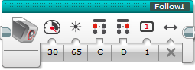

Follow the left of the line (False,🞩), or the right of the line (True, 🗸)

Turning Multiplier.

The higher this number, the faster it will turn.

Lower numbers are better for straight lines.

**No negative numbers.**

Port for front Right wheel

Port for front Left wheel

Light Intensity value to follower

Speed